Dream-Tr_mp New President-Nation Divided
December 6th, 2022

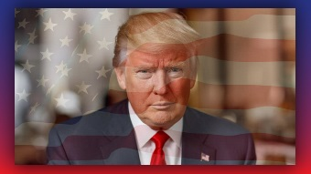
May the Lord bless you, dear ones, your prayers have been so effective.

It looks like there is something wonderful that is about to happen in our nation, as we continue to pray for President Trump that he does not get assassinated. Please continue to pray, every minute you get a chance, in your praying, to please pray for him to stay alive, to be protected, to have God’s protection.

Ezekiel had a dream, just now, and in this dream, President Trump stepped up to a presidential podium with a different seal on the front of it and motioned to a man to come and stand beside him. The man looked very much like John Fitzgerald Kennedy Jr. He looked at the people and he said, "I want you to meet your new Vice President.” He did not announce his name, but most of the people already knew who he was. The Presidential Seal on the podium said The Republic of the United States of America. There was no eagle on it but a dove with an olive branch in its mouth. After he had introduced the Vice President, the people stood to their feet and cheered.

When the crowd settled down, Donald raised his right hand towards Heaven, towards the Lord and looking up he simply said, "True Liberty, and Justice for all."

And then, Ezekiel woke up from the dream and he heard a voice from Heaven saying:

"Oh, rebellious house! For you are a rebellious house, how many times have I told you, how many times have I shown you, how many prophets and saints have I sent to you, but you only make your heart all the harder. Woe to you, rebellious house!"

“I saw Jesus in the clouds,” Ezekiel said. “He was looking down and speaking directly to the Northeastern United States.” The map of the United States looked like a bite had been taken out there from Maine to Maryland, and that fourth of the country declared war against the Republic and that they would fight us to the death, and they also charged Trump, and all the other states behind him, which was three-quarters of the nation, with treason.

I am hoping and praying that this comes about, how wonderful this would be! How powerful our prayers have been, that it is moving in this direction. There may have been more to this, Ezekiel felt like the Lord wanted to add some other details, but he was not sure, so he decided to wait on that.

But I wanted to at least let you know it seems like there is a big and wonderful turnaround coming. Praise be to God!

Please do not stop praying.

Thank you, Heart Dwellers.

